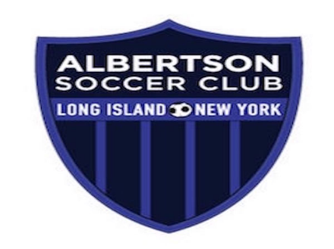

Albertson Travel Program Zero Tolerance Policy
In furtherance of the Albertson Soccer Club's commitment to "Growth Through Good Sportsmanship," the Albertson Travel Program (the "Travel Program") has instituted a "Zero Tolerance Policy" (the "Policy") with respect to any actions by any of its travel coaches (including assistant coaches), trainers, managers, players, parents or others in attendance that is inconsistent with this mission. By way of example only, arguing with, or using indecent language directed at, referees, opposing players or parents of players on opposing teams will not be tolerated; nor will initiating, inciting or participating in fights or similar unsportsmanlike behavior. There will also be zero tolerance for littering the fields or for violating the prohibition against bringing pets to the fields.

The Travel Program reserves the right to, among other things, remove, suspend or fine any travel coaches (including assistant coaches), trainers, managers, players, parents or others in attendance who violate this Policy. Coaches (and assistant coaches), trainers and managers should be clear that they are responsible, and will be held accountable, for the actions of their players, of the parents of their players, and any others in attendance. Such responsibility and accountability includes, but is not limited to, (i) trainers and coaches being responsible for payment of all fines imposed by Long Island Junior Socer League, Eastern New York Youth Soccer Association, or any other regulatory authority based on their actions or inaction, and (ii) team managers being responsible for all fines imposed by virtue of their actions or inaction, or those of parents or players on their teams. This Policy is effective immediately. By coaching this season and thereafter, all Coaches (and assistant coaches), trainers and managers will be deemed to have consented to acting fully in accordance with this Policy.

Player Contract
As a member of the Albertson Soccer Club I pledge to:
- Come to all practices, training sessions and games prepared to play, ready to listen and equipped with a ball, shin guards, water and appropriate dress / uniform.
- Be respectful to all players on my team and other teams.
- Be respectful to all coaches and referees.
- Refrain from using abusive and/or taunting language while at practice, before, during and after a game.
- Refrain from physical abuse of other players, coaches, referees, parents and spectators while at practice, before, during and after a game.
- Support the team and other teammates by following the game while on the sidelines.
Parent Contract
As a parent of an Albertson Soccer Club player, I pledge to:
- Support my child’s efforts to be on time and be prepared for all practices, training sessions and games.
- Calmly watch the play and not shout instructions to my child or other players.
- Not question the calls of the referee or the actions of the coach.
- Provide encouragement to my child and all team players.
- Be respectful of all players on my child’s team and opposing teams, coaches and referees.
- Discuss all issues with my child’s coach privately and at a time away from the game.
- Refrain from unsportsmanlike and poor parenting behavior including verbal or physical abuse of players, coaches, referees and other spectators at practice, before, during and after games.
I, the parent of the registrant, a minor, agree that the registrant and I will abide by the rules of the Albertson Soccer Club (Club). In consideration of the Club accepting the registrant for its soccer program and associated activities, I hereby release, discharge and/or otherwise indemnify the Club, it's affiliated organizations and sponsors, their employees and associated personnel, including the owners of fields and facilities used for Club activities, against any claim by or on behalf of the registrant as a result of the registrant's participation in Club games, activities, and/or being transported to or from the same, which transportation I hereby authorize.
In the event of an accident, injury, sickness, etc. to my child, I hereby give my permission for any and all medical attention necessary to be administered to my child under the direction of all persons listed on the medical release or any duly licensed Doctor of Medicine until such time this permission is revoked in writing from the date hereof. I hereby assume responsibility for payment for any such treatment.
I agree that Albertson Soccer Club (“ASC”) and its agents reserve the right to take and utilize photographs, videos, or any other type of recordings of participating children and their parents, caregivers, or anyone accompanying them to any trainings/games. I consent to ASC’s use of the photographs, videos, or recordings of my child, me, or any guardian I have designated for advertising, promotional or other related purposes. I expressly waive all rights to compensation and other rights which may arise as a result (including any rights under N.Y. Civil Rights Law 50).

