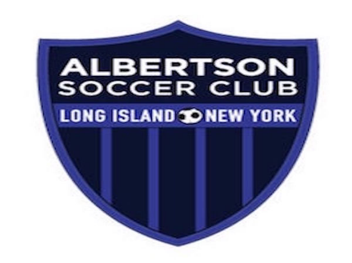

ALBERTSON FURY/ ALBERTSON ECNL PARENT CODE OF CONDUCT
As a proud Albertson Fury Youth Parent, I will:
1. Support my child with positive encouragement at all times.
2. Respect and adhere to the ideals, policies, and rules determined by Albertson Fury, Albertson Soccer Club and my child’s team.
3. Maintain self-control at all times.
4. Respect the facilities, either home or away, in which my child is privileged to play.
5. Show respect for the decisions, judgment and authority of the officials.
6. Exhibit a high degree of sportsmanship, teamwork and positive attitude at all times when representing my child, the team and the club.
7. Refrain from coaching from the sidelines during training and or games.
8. Respect the 24-hour rule when dealing with issues and concerns I have that I need to address with a coach or administrator (must wait at least 24hrs to connect with a coach or administrator following a game, training session)
9. Refrain from expressing my opinion of the coaches or players in front of my own child or in a public setting.
10. Refrain from using foul language or racially motivated comments towards other parents, coaches, officials or opponents.
11. Refrain from yelling at or threatening referees, opposing players or coaches before, during, or after games or training.
12. Will not use social media to express any negativity toward anyone associated with Albertson Fury, Albertson Soccer Club or any Leagues that we participate in.
13. Will Pay club and team fees in accordance with required schedules.
14. Not physically abuse any other person.
15. Accept defeat gracefully.
16. Will not bring alcohol, illegal substances, tobacco or firearms to any Albertson/Albertson Fury game, function or activity.
17. Understand that ASC parents are responsible for the behavior of all of their team’s guests/spectators and that they shall act in accordance with this Code of Conduct.
18. Give timely notice and reason to my coach/manager as to why my player would be unable to attend a team event.
19. Remember that the game is about my child, not about me.
Anyone who violates this Code of Conduct is subject to immediate dismissal from any game and disciplinary action up to and including being expelled from the club.
I have read this agreement and accept this agreement as part of my commitment to Albertson Soccer Club/Albertson Fury and acknowledge the consequences of not abiding by this agreement.

Parent Signature_______________________________________________

Date________________________________________________________

Parent Signature_______________________________________________

Date________________________________________________________

